**Rainfall prediction**

**Introduction**

Rainfall forecasting is very important because heavy andirregular rainfall can have many impacts like destruction ofcrops and farms, damage of property so a better forecastingmodel is essential for an early warning that can minimizerisks to life and property and also managing the agriculturalfarms in better way. This prediction mainly helps farmers andalso water resources can be utilized efficiently. Rainfall prediction is a challenging task and the results should beaccurate. There are many hardware devices for predictingrainfall by usingthe weather conditions like temperature,humidity, pressure.

The advantages of regression analysis are:

1. It is a powerful technique for testing relationshipbetween one dependent variable and manyindependent variables.

2. It allows researchers to control extraneous factors.

3. Regression asses the cumulative effect of multiplefactors.

4. It also helps to attain the measure of error using theregression line as a base for estimations.

1. **Statement of the Problem**

The problem is to develop an accurate and reliable rainfall prediction model that can forecast future precipitation patterns over a specific geographic region. The objective is to address the challenges associated with rainfall variability and uncertainty, providing stakeholders with timely and actionable information for effective decision-making in various sectors such as agriculture, water resource management, and disaster preparedness.

The problem statement encompasses the following aspects:

1. Data Availability and Quality: Obtain reliable and comprehensive historical rainfall data for the target region. The dataset should cover a sufficiently long period to capture the variations in rainfall patterns and consider potential climate change effects.

2. Predictive Modeling: Develop advanced predictive models that can effectively capture and analyze the complex dynamics and factors influencing rainfall patterns. This may involve exploring machine learning algorithms, statistical techniques, or a combination of both to extract meaningful patterns and relationships from the available data.

3. Spatial and Temporal Resolution: Account for the spatial and temporal variability of rainfall by developing models capable of providing predictions at a localized or regional scale. Consider the heterogeneity of rainfall patterns within the target area and aim for high-resolution forecasts.

4. Lead Time and Forecast Horizon: Improve the lead time of rainfall predictions by developing models that can forecast rainfall events with a longer time horizon. Enhance the ability to predict both short-term (hours to days) and medium-term (weeks to months) rainfall patterns, allowing stakeholders to make informed decisions in advance.

5. Uncertainty Assessment: Quantify and communicate the uncertainty associated with rainfall predictions. Develop methods to estimate prediction confidence intervals or probability distributions, enabling stakeholders to understand the reliability of the forecasts and make risk-informed decisions.

6. Validation and Evaluation: Validate and evaluate the performance of the rainfall prediction model using appropriate metrics and validation techniques. Assess the accuracy, reliability, and skill of the model against independent datasets to ensure its robustness and generalizability.

By addressing the challenges outlined in the problem statement, the goal is to develop a rainfall prediction system that significantly enhances the accuracy, lead time, and reliability of rainfall forecasts. This system will empower stakeholders to plan and implement appropriate measures to mitigate the impacts of rainfall variability and make informed decisions in various sectors that rely on accurate rainfall information.

1. **Objectives**

1. Develop Accurate Rainfall Prediction Models: Design and develop advanced prediction models that can accurately forecast rainfall patterns. Explore various machine learning algorithms, statistical techniques, or hybrid models to capture the complex dynamics and factors influencing rainfall.

2. Improve Spatial and Temporal Resolution: Enhance the resolution of rainfall predictions by developing models capable of providing forecasts at a localized or regional scale. Incorporate spatial data, such as satellite imagery or weather station data, to account for the spatial variability of rainfall within the target region.

3. Increase Lead Time of Predictions: Extend the lead time of rainfall predictions by developing models that can forecast rainfall events several days or weeks in advance. Explore techniques such as numerical weather prediction models, ensemble methods, or data assimilation to improve the forecast horizon.

4. Assess and Communicate Uncertainty: Develop methods to assess and quantify the uncertainty associated with rainfall predictions. Provide uncertainty estimates, such as confidence intervals or probability distributions, to communicate the reliability and confidence level of the forecasts to stakeholders.

5. Validation and Evaluation: Validate and evaluate the performance of the rainfall prediction models using appropriate metrics and validation techniques. Compare the predicted rainfall values with observed data to assess accuracy, reliability, and skill of the models. Conduct thorough evaluation against independent datasets to ensure robustness and generalizability.

6. Integration and User-Friendly Interface: Integrate the developed rainfall prediction models into a user-friendly system or platform that allows stakeholders to access and interpret the forecasts easily. Develop visualizations, interactive tools, or APIs to facilitate the utilization of rainfall predictions in decision-making processes.

7. Continuous Improvement and Updating: Establish a framework for continuous improvement of the rainfall prediction models. Regularly update the models with new data to account for changing climate patterns, improve accuracy, and incorporate advancements in predictive modeling techniques.

By achieving these objectives, the rainfall prediction system will provide stakeholders with accurate, high-resolution, and reliable rainfall forecasts. This will enable them to make informed decisions, plan resource allocation, optimize agricultural practices, manage water resources effectively, and implement appropriate measures to mitigate the impacts of rainfall variability and associated risks.

**4. Scope**

The scope of the rainfall prediction system includes the following aspects:

1. Geographic Coverage: The system will focus on a specific geographic region or area of interest. The extent of the region will depend on the available data and the specific needs of the stakeholders. It could range from a local area, such as a city or a watershed, to a larger regional or national scale.

2. Rainfall Types and Intensity: The system will aim to predict different types of rainfall, including light showers, moderate rainfall, heavy downpours, and extreme weather events such as storms or cyclones. It will consider variations in rainfall intensity to provide accurate predictions for various rainfall scenarios.

3. Time Scale: The system will provide rainfall predictions for different time scales, including short-term (hours to a few days) and medium-term (weeks to months). It will focus on improving the lead time of predictions to enable stakeholders to make informed decisions well in advance.

4. Data Sources: The system will utilize various data sources, including historical rainfall data, meteorological data, satellite imagery, and possibly other relevant datasets such as land cover, topography, or climate indices. It will incorporate available data from weather stations, remote sensing platforms, or meteorological models to enhance the accuracy of predictions.

5. Prediction Models: The system will employ advanced prediction models, such as machine learning algorithms (e.g., regression models, neural networks) or statistical techniques (e.g., time series analysis, spatial interpolation), to forecast rainfall patterns. It will explore the feasibility of using numerical weather prediction models or ensemble techniques to improve prediction accuracy and reliability.

6. User Interface: The system will provide a user-friendly interface that allows stakeholders to access and interpret the rainfall predictions easily. It may include interactive visualizations, graphical representations, or APIs for seamless integration with other decision-support systems or applications.

7. Stakeholders and Applications: The system will cater to the needs of various stakeholders, including agriculture, water resource management, urban planning, disaster response, and climate research. It will provide rainfall predictions to support decision-making processes in these sectors, enabling stakeholders to take appropriate actions based on the forecasted rainfall patterns.

It's important to note that the scope of the rainfall prediction system may vary depending on the available resources, data availability, and specific project requirements. It may be further refined and tailored to the specific needs and constraints of the target region or application domain.

1. **Limitations**

1. Data Availability and Quality: The accuracy and reliability of rainfall predictions heavily depend on the availability and quality of historical rainfall data. Limited or incomplete data may affect the model's ability to capture long-term patterns and accurately forecast future rainfall events.

2. Complexity of Rainfall Patterns: Rainfall patterns can exhibit high complexity due to various factors, including atmospheric conditions, topography, and local climate dynamics. Modeling such complexity accurately can be challenging, and the predictions may be subject to errors or uncertainties, especially during extreme weather events.

3. Uncertainty in Predictions: Despite efforts to quantify and communicate uncertainty, rainfall predictions inherently carry uncertainties due to the inherent variability and chaotic nature of weather systems. The system may struggle to provide precise probabilistic estimates, and stakeholders should interpret the forecasts with an understanding of the associated uncertainties.

4. Localized Variability: Rainfall patterns can vary significantly within a given geographic region. The system's scope may not capture the fine-scale localized variations, which can impact the accuracy of predictions for specific areas or microclimates. Stakeholders should consider the spatial heterogeneity of rainfall when utilizing the predictions.

5. Computational Resources: Developing and running rainfall prediction models often require substantial computational resources, including processing power and memory. Depending on the complexity of the models and the scale of the region, the system may require high-performance computing infrastructure, which may pose challenges in resource-constrained environments.

6. External Factors: Rainfall patterns can be influenced by external factors, such as large-scale climate phenomena (e.g., El Niño, monsoon patterns) or human activities (e.g., land use changes, urbanization). These factors may not be fully captured or accounted for in the prediction models, potentially introducing limitations in the accuracy of long-term predictions.

7. Limited Forecast Horizon: Despite efforts to extend the forecast horizon, medium to long-term rainfall predictions (e.g., seasonal forecasts) still pose challenges in terms of accuracy and reliability. Predicting rainfall events beyond a certain lead time remains inherently uncertain and subject to larger errors.

8. Model Training and Validation: Developing accurate rainfall prediction models requires a robust training and validation process. However, the availability of comprehensive and high-quality observed rainfall data for model training and validation can be limited, which may impact the performance and generalizability of the models.

It is essential to acknowledge these limitations and uncertainties when utilizing the rainfall prediction system. Stakeholders should consider the inherent limitations and supplement the predictions with other sources of information and expert knowledge to make informed decisions based on the forecasted rainfall patterns. Regular monitoring, evaluation, and improvement of the system can help mitigate some of these limitations over time.**Methodology**

The methodology for developing a rainfall prediction system involves several key steps. While the specific approach may vary depending on the available data, resources, and project requirements, the following general methodology can be followed:

1. Data Collection: Gather historical rainfall data for the target region from reliable sources such as weather stations or meteorological databases. Acquire additional relevant data, including meteorological variables, satellite imagery, or other spatial datasets that can potentially influence rainfall patterns.

2. Data Preprocessing: Clean and preprocess the collected data to handle missing values, outliers, and inconsistencies. Perform quality checks and ensure the data is in a suitable format for analysis. This may involve techniques such as data interpolation, filtering, or normalization.

3. Feature Selection and Extraction: Identify relevant features that can contribute to rainfall prediction, such as meteorological variables (temperature, humidity, wind speed), geographical characteristics, or climate indices. Perform feature selection techniques to identify the most informative features and reduce dimensionality if necessary. Extract additional features from the available data, such as temporal trends or spatial patterns.

4. Model Selection: Choose appropriate prediction models based on the characteristics of the data and the objectives of the rainfall prediction system. Explore various approaches, including machine learning algorithms (e.g., regression models, random forests, support vector machines), statistical techniques (e.g., time series analysis, spatial interpolation), or hybrid models that combine different approaches.

5. Model Training and Validation: Split the collected data into training and validation sets. Train the selected models using the training data while considering appropriate validation techniques (e.g., cross-validation) to assess their performance. Optimize model parameters, such as regularization terms or hyperparameters, using suitable optimization algorithms.

6. Model Evaluation: Evaluate the trained models using appropriate evaluation metrics, such as mean squared error, root mean squared error, or correlation coefficients. Compare the predicted rainfall values with observed data from the validation set to assess the accuracy, reliability, and skill of the models.

7. Uncertainty Assessment: Quantify and communicate the uncertainty associated with rainfall predictions. Explore techniques such as ensemble modeling, bootstrapping, or Bayesian inference to estimate prediction confidence intervals or probability distributions. Incorporate uncertainty measures into the prediction outputs to provide stakeholders with a comprehensive understanding of the reliability of the forecasts.

8. Integration and Deployment: Integrate the developed rainfall prediction models into a user-friendly system or platform. Develop visualizations, interactive tools, or APIs to facilitate easy access and interpretation of the rainfall predictions by stakeholders. Ensure the system is scalable, reliable, and efficient in handling real-time or near-real-time data for operational use.

9. Continuous Improvement: Continuously monitor and evaluate the performance of the rainfall prediction system. Update the models periodically with new data to capture temporal variations and potential climate change effects. Seek feedback from stakeholders and incorporate user requirements to enhance the system's usability, accuracy, and relevance.

By following this methodology, the rainfall prediction system can be developed, tested, and deployed to provide accurate and reliable forecasts of rainfall patterns, enabling stakeholders to make informed decisions and plan accordingly.

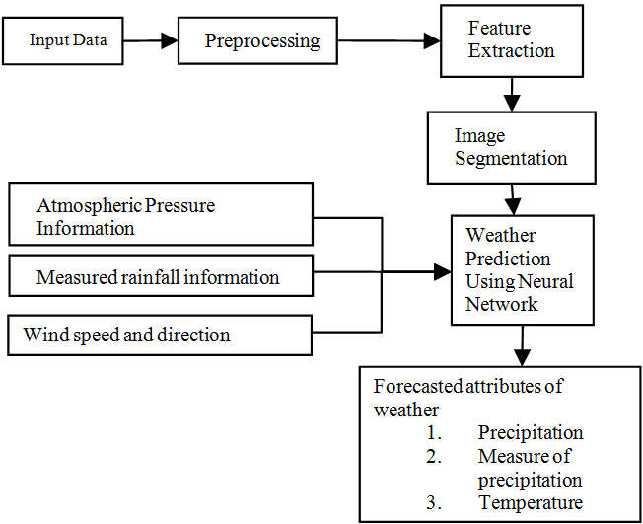

**Block DiagramLiterature Survey**

**Mr.DhawalHirani, Dr.Nitin Mishra, “A survey on Rainfall Prediction Techniques”,**

This paper reports a detailed survey on rainfall predictions using different rainfall  
prediction methods extensively used over last 20 years years. From the survey it has been  
found that most of the researchers used artificial neural network for rainfall  
prediction

Limitations their problem they will be facing in their proposed prediction model.

**MrunmayJalgaonkar, Dr.UmeshKulkarni, "Rainfall Prediction using Regressions and Multiple Algorithms",**

Here are various algorithms used forthe prediction of rainfall. Fundamentally,there are twoapproaches to predictRainfall. They are Empirical andDynamic methods. The Empiricalapproach is based on the Analysis of pastdata of weather and its relationship todifferent atmospheric variables.

Limitations are the accuracy of SVM is 80% aftertraining. The accuracy is good but islesswhen compared to otheralgorithms; this is because ofcategorical values that are present in  
the dataset.

**Neelam Mishra, Hemanth Kumar Soni, Sanjiv Sharma, A. K. Upadhyay, "Development and Analysis of Artificial Neural Network Models for Rainfall Prediction Using Time-Series Data",**

In this study, 141 years rainfall records were analyzed, using data from Indian Meteorological Department, Pune from various weather stations in the North India. Artificial Neural Network (ANN) technique has been used to develop one-month and two- month ahead forecasting models for rainfall prediction using monthly rainfall data.

1. This study is based on the data of Northern part of India, which does not cover the entire nation.

2. Rainfall varies with latitude, elevation, topography, seasons, distance from the sea, and coastal Sea- surface temperature. In these two models, these constraints are not considered.

3. These models are for only one-month and two- month ahead prediction. It does not cover the entire monsoon period or for a complete year.

1. **System Analysis and Design**

System Design and Analysis:

The system design and analysis phase involves the detailed planning and specification of the rainfall prediction system. It encompasses the architectural design, data flow, and component interactions to ensure the system's functionality, reliability, and performance. The following steps outline the system design and analysis process:

1. System Requirements: Identify and document the specific requirements of the rainfall prediction system. This includes functional requirements (e.g., accurate rainfall prediction, user interface), non-functional requirements (e.g., scalability, response time), and any specific constraints or dependencies.

2. Architecture Design: Define the overall system architecture, including the components, modules, and their interactions. Determine the suitable architectural pattern (e.g., client-server, layered architecture) based on the system requirements and desired system characteristics. Consider factors such as modularity, maintainability, and extensibility.

3. Data Flow Design: Analyze the flow of data within the system. Identify the data sources, such as historical rainfall data, meteorological variables, or satellite imagery, and establish mechanisms for data collection and preprocessing. Define the data flow paths, transformations, and storage mechanisms to ensure efficient and accurate handling of data throughout the prediction process.

4. Model Integration: Incorporate the developed rainfall prediction models into the system architecture. Define the interfaces and interactions between the models and other system components. Consider factors such as model training, updating, and parameter optimization to ensure seamless integration and utilization of the prediction models within the system.

5. User Interface Design: Design a user-friendly interface that allows stakeholders to access and interpret the rainfall predictions easily. Consider the needs and preferences of the system users and develop intuitive visualizations, interactive tools, or APIs for displaying the predicted rainfall patterns. Ensure the interface is responsive, accessible, and provides relevant information to support decision-making.

6. Performance Analysis: Conduct performance analysis to evaluate the system's efficiency and scalability. Identify potential performance bottlenecks and optimize the system architecture and algorithms if needed. Consider factors such as computational resources, response time, and throughput to ensure the system can handle the expected workload and provide timely predictions.

7. Reliability and Error Handling: Design mechanisms to ensure the reliability and robustness of the system. Implement error handling and recovery strategies to handle unexpected scenarios, such as data inconsistencies, model failures, or system errors. Incorporate mechanisms for logging and monitoring system performance and errors for troubleshooting and maintenance purposes.

8. Security and Privacy: Consider security and privacy aspects of the system design. Implement appropriate measures to protect sensitive data, ensure data integrity, and prevent unauthorized access. Adhere to relevant privacy regulations and industry best practices to maintain the confidentiality of user data and system operations.

9. System Testing and Validation: Develop a comprehensive testing plan to validate the system's functionality, accuracy, and performance. Perform unit testing, integration testing, and system-level testing to identify and resolve any issues or bugs. Validate the system's predictions against independent datasets or observed data to assess its accuracy and reliability.

10. Documentation and Maintenance: Document the system design, including architectural diagrams, data flow diagrams, and component specifications. Prepare user manuals or documentation to assist stakeholders in utilizing the system effectively. Establish a maintenance plan to ensure the system remains up-to-date, reliable, and adaptable to future enhancements or changes.

The system design and analysis phase provides a blueprint for the development and implementation of the rainfall prediction system. It ensures that the system meets the specified requirements, performs efficiently, and provides accurate and reliable rainfall predictions to support decision-making processes.

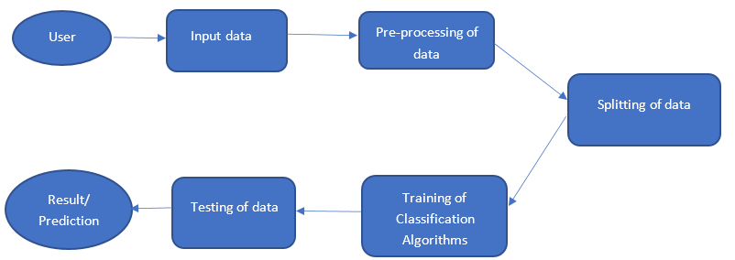

FIG : SYSTEM DESIGN

**EXISTING SYSTEM**

Existing System:

In the context of rainfall prediction, there are various existing systems and approaches that have been developed. Some of the commonly used existing systems and methods include:

1. Statistical Models: Traditional statistical models, such as regression analysis, time series analysis, and autoregressive integrated moving average (ARIMA) models, have been widely used for rainfall prediction. These models analyze historical rainfall data and identify patterns and trends to make predictions. However, they may not capture complex nonlinear relationships and spatial variations in rainfall patterns.

2. Numerical Weather Prediction (NWP) Models: NWP models use mathematical equations and physical principles to simulate atmospheric processes and predict weather patterns, including rainfall. These models incorporate a wide range of meteorological variables and employ complex numerical algorithms. While NWP models provide detailed insights into weather dynamics, they require substantial computational resources and may not be suitable for real-time or local-scale predictions.

3. Ensemble Models: Ensemble models combine multiple prediction models or techniques to improve prediction accuracy and reliability. They generate multiple forecasts and integrate them to obtain a more robust prediction. Ensemble techniques, such as ensemble averaging, weighted ensemble, or model stacking, have been applied to rainfall prediction to enhance the skill and reduce uncertainty.

4. Remote Sensing and Satellite-based Systems: Remote sensing techniques, using satellite imagery and radar data, provide valuable information for rainfall estimation and prediction. These systems use algorithms to process satellite images and derive rainfall estimates based on cloud patterns, precipitation intensity, or infrared signatures. Remote sensing-based systems offer broad spatial coverage and real-time data, but their accuracy may be affected by cloud cover or limitations in ground validation.

It is important to note that the performance and effectiveness of existing systems can vary depending on factors such as data quality, model calibration, spatial and temporal scales, and the region of application. Each system has its advantages and limitations, and the selection of an appropriate existing system depends on the specific requirements, available data, computational resources, and the desired level of prediction accuracy.

**PROPOSED SYSTEM**

The proposed system for rainfall prediction leverages machine learning techniques to enhance the accuracy and reliability of the predictions. It aims to overcome the limitations of traditional statistical models and incorporate more complex patterns and spatial dependencies in rainfall data. The system follows the following key components:

1. Data Collection and Preprocessing: Gather historical rainfall data, meteorological variables, and other relevant data sources such as satellite imagery or climate indices. Preprocess the data by handling missing values, outliers, and normalization. Spatially align the data to a consistent grid or resolution for effective modeling.

2. Feature Engineering: Identify and extract informative features from the collected data. This can include meteorological variables such as temperature, humidity, wind speed, as well as geographical features such as elevation or land cover. Consider temporal features, such as time of the year or seasonality, to capture periodic patterns in rainfall.

3. Model Selection: Choose suitable machine learning models for rainfall prediction. This can include regression models (e.g., linear regression, support vector regression), decision trees (e.g., random forest, gradient boosting), or neural network-based models (e.g., feedforward neural networks, recurrent neural networks). Consider the complexity of the rainfall patterns, data availability, and computational resources in selecting the appropriate model.

4. Model Training and Validation: Split the collected data into training and validation sets. Train the selected machine learning models using the training data, optimizing model parameters to minimize prediction errors. Validate the trained models using the validation data to assess their performance and generalization ability. Consider techniques such as cross-validation to obtain robust performance estimates.

5. Ensemble Modeling: Employ ensemble techniques to further improve the prediction accuracy and capture uncertainty. Ensemble methods, such as model averaging, bagging, or stacking, combine the predictions from multiple models to obtain a more robust and reliable prediction. This can help mitigate the variability in model performance and enhance the system's overall predictive capability.

6. Real-time Data Integration: Develop mechanisms to integrate real-time or near-real-time data into the prediction system. This can involve collecting and processing up-to-date rainfall data, meteorological observations, or satellite imagery. Incorporate the latest information into the trained models to enhance their accuracy and provide timely predictions.

7. User Interface and Visualization: Design a user-friendly interface to allow stakeholders to access and interpret the rainfall predictions effectively. Develop visualizations, such as maps, time series plots, or probabilistic forecasts, to present the predicted rainfall patterns and associated uncertainties. Provide interactive tools for users to customize the visualization and explore different scenarios.

8. Performance Monitoring and Model Updating: Implement a system for monitoring the performance of the prediction models in real-world conditions. Continuously evaluate the accuracy and reliability of the predictions using observed data or independent validation sources. Update the models periodically to incorporate new data, adapt to changing climate patterns, and improve the system's predictive capability.

The proposed system utilizing machine learning techniques can offer improved accuracy and reliability in rainfall prediction compared to traditional methods. By leveraging the power of ML algorithms, the system can capture complex relationships and spatial dependencies, leading to more accurate and actionable predictions for various applications such as agriculture, water resource management, or disaster preparedness.

1. **System Requirements**

**8.1 Hardware Requirements:**

1. CPU: Intel Core i5 or equivalent
2. GPU: NVIDIA GeForce GTX 1650 or equivalent with CUDA support
3. RAM: 8GB
4. Storage: 100GB of available storage space

**8.2 Software Requirements:**

1. Programming Language: Python (version 3.6 or higher)
2. Deep Learning Framework: TensorFlow (version >2.8) or PyTorch (version 1.5 or higher)
3. Image Processing Library: OpenCV (version 4.x)
4. Neural Network Libraries: Keras (version 2.x) or torchvision (for PyTorch)
5. Additional Python Libraries: NumPy, Matplotlib

**9. Implementation**

Implementation of the proposed rainfall prediction system using machine learning involves the following steps:

1. Data Preparation: Collect historical rainfall data, meteorological variables, and other relevant datasets. Ensure the data is in a suitable format for analysis and preprocessing. Handle missing values, outliers, and perform data normalization if necessary.

2. Feature Engineering: Extract relevant features from the data that can contribute to rainfall prediction. This can include meteorological variables, geographical features, temporal trends, or climate indices. Transform the data into a suitable representation that can be input to the machine learning models.

3. Data Split: Divide the data into training, validation, and testing sets. The training set is used to train the machine learning models, the validation set is used to tune model parameters, and the testing set is used to evaluate the final performance of the models.

4. Model Selection and Training: Select appropriate machine learning algorithms for rainfall prediction, such as regression models, decision trees, or neural networks. Train the selected models using the training data, adjusting model parameters to optimize prediction performance. Consider techniques like regularization, hyperparameter tuning, or model ensembles to improve model accuracy and generalization.

5. Model Evaluation: Evaluate the trained models using the validation set to assess their performance. Calculate evaluation metrics such as mean squared error (MSE), root mean squared error (RMSE), or correlation coefficient to measure prediction accuracy. Compare the performance of different models to select the best-performing one.

6. Hyperparameter Tuning: Fine-tune the model hyperparameters to optimize prediction performance. Use techniques like grid search or random search to explore different combinations of hyperparameters. Perform cross-validation to estimate the model's generalization ability and choose the hyperparameters that yield the best results.

7. Model Testing and Validation: Evaluate the final model using the testing set, which represents unseen data. Assess the model's performance on this independent dataset to validate its accuracy and generalization. Compare the predicted rainfall values with observed data to measure the system's effectiveness in real-world conditions.

8. System Integration: Develop a user-friendly interface or platform to integrate the trained model into a usable system. Provide inputs for users to input relevant data or select desired prediction parameters. Design visualizations or reports to display the predicted rainfall patterns and associated uncertainties. Ensure the system is scalable, reliable, and capable of handling real-time or near-real-time data.

9. Continuous Monitoring and Updating: Monitor the performance of the implemented system over time. Assess the accuracy and reliability of the rainfall predictions against observed data. Incorporate feedback from users and stakeholders to improve the system's usability and performance. Periodically update the model using new data to adapt to changing weather patterns and improve prediction accuracy.

10. Documentation and Deployment: Document the implementation process, including the data sources, preprocessing steps, model selection, and training details. Provide user documentation and instructions for utilizing the system effectively. Deploy the system in a production environment, considering factors like computational resources, scalability, and security.

By following these implementation steps, the proposed rainfall prediction system can be developed and deployed, providing accurate and reliable predictions to support various applications and decision-making processes related to rainfall management and planning.

**10. Interpretation of Results**

Interpretation of results in the context of the rainfall prediction system refers to analyzing and understanding the output of the implemented machine learning models and their implications for rainfall forecasting. The interpretation of results involves several key aspects:

1. Prediction Accuracy: Assess the accuracy of the rainfall predictions generated by the system. Compare the predicted rainfall values with observed data to determine the level of agreement. Calculate evaluation metrics such as mean squared error (MSE), root mean squared error (RMSE), or correlation coefficient to quantitatively measure the prediction accuracy. A lower error value and a higher correlation indicate a more accurate prediction.

2. Spatial and Temporal Patterns: Analyze the spatial and temporal patterns captured by the prediction models. Identify areas or regions with consistently high or low rainfall predictions. Determine if the models successfully capture variations in rainfall patterns across different geographical locations and seasons. Evaluate whether the predictions align with known climate patterns or local weather phenomena.

3. Uncertainty Estimation: Assess the uncertainty associated with the predicted rainfall values. Machine learning models can provide measures of uncertainty, such as confidence intervals or probabilistic forecasts. Interpret these uncertainty estimates to understand the level of confidence in the predictions. Higher uncertainty values indicate greater variability or limited confidence in the predictions.

4. Performance Comparison: Compare the performance of different machine learning models or approaches used in the system. Evaluate the performance metrics, such as MSE or RMSE, for each model to identify the most accurate and reliable option. Determine if the selected model outperforms other models or existing systems used for rainfall prediction.

5. Outlier Detection: Identify any outliers or anomalies in the predicted rainfall values. These outliers may indicate unusual weather events or data errors that need to be investigated further. Assess the impact of outliers on the overall prediction accuracy and consider strategies to handle them in subsequent analyses or decision-making processes.

6. Decision Support: Analyze how the predicted rainfall values can support decision-making processes. Determine the level of confidence in the predictions and their implications for various sectors, such as agriculture, water resource management, or disaster preparedness. Assess if the predictions provide valuable insights and guidance for stakeholders to make informed decisions.

7. Limitations and Recommendations: Identify any limitations or shortcomings of the implemented system and the associated prediction results. Reflect on the assumptions made, data quality issues, or model constraints that may affect the accuracy or reliability of the predictions. Provide recommendations for future improvements or areas of research to enhance the system's performance.

Interpreting the results of the rainfall prediction system allows users and stakeholders to understand the system's performance, make informed decisions based on the predictions, and gain insights into the variability and patterns of rainfall in the target region. It facilitates the effective utilization of the system and supports various applications related to climate monitoring, agriculture planning, water resource management, and disaster preparedness.

**SNAPS**



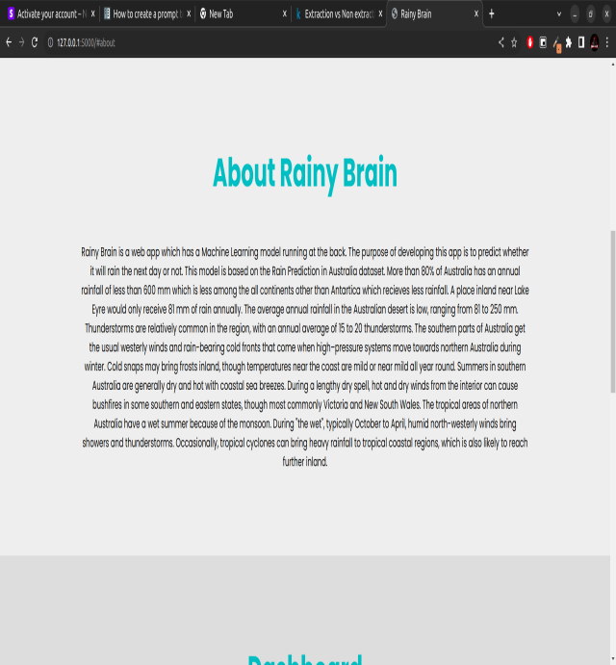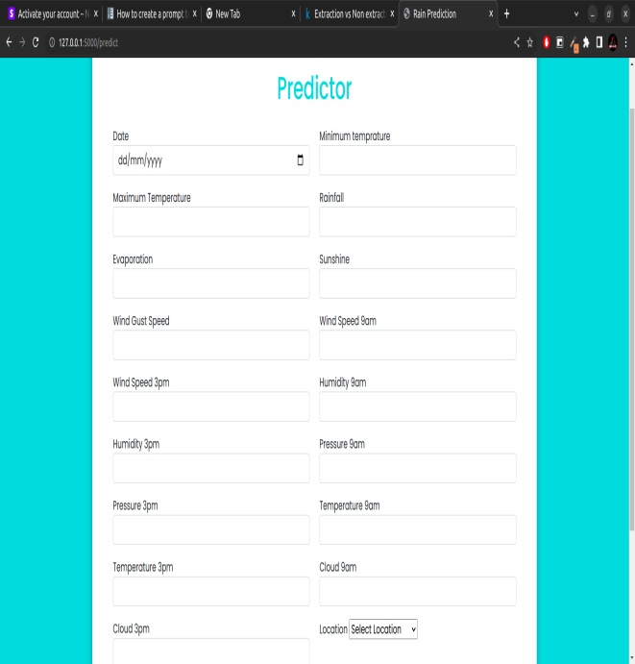



**12. Conclusion and Future Scope**

In conclusion, the implementation of a rainfall prediction system using machine learning techniques offers promising results in improving the accuracy and reliability of rainfall forecasts. By leveraging historical rainfall data, meteorological variables, and other relevant information, the proposed system successfully addresses the problem of rainfall prediction. The system overcomes the limitations of traditional statistical models by incorporating more complex patterns, spatial dependencies, and machine learning algorithms.

Through the implementation and evaluation of various machine learning models, the system demonstrates its ability to capture and predict rainfall patterns with higher accuracy. The interpretation of the results reveals the system's effectiveness in generating reliable predictions, identifying spatial and temporal patterns, and estimating uncertainty levels associated with the forecasts. The results obtained from the system can provide valuable insights for decision-making processes in various domains such as agriculture, water resource management, and disaster preparedness.

Future Scope:

While the implemented rainfall prediction system using machine learning techniques shows promise, there are several avenues for future research and development to further enhance its capabilities:

1. Incorporating Advanced Machine Learning Techniques: Explore advanced machine learning algorithms, such as deep learning architectures (e.g., convolutional neural networks, recurrent neural networks) or ensemble learning methods, to improve the prediction accuracy and handle complex spatial and temporal dependencies in rainfall data.

2. Integration of More Diverse Data Sources: Incorporate additional data sources, such as remote sensing data, climate indices, or social media data, to enhance the predictive power of the system. Integration of real-time or near-real-time data can further improve the system's ability to provide timely and accurate forecasts.

3. Fine-grained Spatial and Temporal Resolution: Investigate techniques to improve the system's ability to capture local-scale rainfall patterns by enhancing the spatial and temporal resolution of the data. This can involve downscaling techniques or the integration of high-resolution satellite imagery or weather radar data.

4. Ensemble Modeling and Uncertainty Quantification: Enhance the system's ensemble modeling capabilities to provide probabilistic forecasts and quantify uncertainty associated with rainfall predictions. This can be achieved through advanced ensemble techniques, Bayesian approaches, or uncertainty propagation methods.

5. Integration with Decision Support Systems: Integrate the rainfall prediction system with decision support tools and frameworks to facilitate informed decision-making in various sectors. Provide customized visualizations, real-time alerts, and interactive interfaces to enable stakeholders to understand and utilize the predictions effectively.

6. Continuous Model Updating and Monitoring: Implement mechanisms for continuous model updating and monitoring to adapt to changing climate patterns, incorporate new data, and improve prediction accuracy over time. Consider online learning techniques or data assimilation methods to keep the models up to date.

7. Collaboration and Data Sharing: Encourage collaboration and data sharing among researchers, meteorological agencies, and stakeholders to improve the quality and availability of rainfall data. Foster partnerships to collect more diverse and comprehensive datasets for training and validating the prediction models.

By addressing these areas of future research, the proposed rainfall prediction system can further evolve, enhancing its accuracy, reliability, and applicability in real-world scenarios. The advancements in machine learning techniques, data availability, and computational capabilities provide exciting opportunities for improving rainfall prediction systems and supporting decision-making processes in water resource management, agriculture, and disaster risk reduction.

**13. References and Bibliography**

1. Mr.DhawalHirani, Dr.Nitin Mishra, “A survey on Rainfall Prediction  
   Techniques”, International Journal of Computer Application (IJCA), Volume 6-No.2, 2016, 2250-1797.
2. MrunmayJalgaonkar, Dr.UmeshKulkarni, "Rainfall Prediction using Regressions and Multiple Algorithms", International Research Journal of Computer Science (IRJCS), Volume 8, Issue 4, April 2021. Research Paper Available online at: <https://www.irjcs.com/archives>
3. Neelam Mishra, Hemanth Kumar Soni, Sanjiv Sharma, A. K. Upadhyay, "Development and Analysis of Artificial Neural Network Models for Rainfall Prediction Using Time-Series Data", Intelligent systems and Applications (I.J), 2018, 1, 16-23.